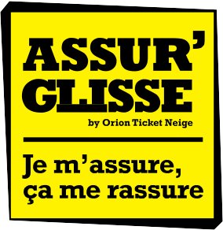
CLAIM FORM

Coupon to be returned in 15 days to: Gras Savoye Montagne
3B, rue de l’Octant - B.P. 279 - 38433 Echirolles Cedex

Tel. +33 (0)9 72 72 22 45

Name of the resort: .......................................................................................................................................................................

Name: ................................................................................... First name: .......................................................................................

Date of birth: ...................................................................................................................................................................................

Permanent address: ........................................................................................................................................................................

Postal code: ................................. Town: .............................. Country: .........................................................................................

Tel. ........................................................................................ Mobile : ..........................................................................................

E-mail : ...........................................................................................................................................................................................

Name and address of legal guardian for a child: ....................................................................................................................................

.......................................................................................................................................................................................................

Type of lift pass: One-day | Several days |  | Were you transported in an ambulance? | Yes | No
Do you have Social Security cover? | Yes | No | If yes: To the doctor’s surgery

Do you have complimentary health insurance? Yes No

If yes, please give name and address: ......................................

..............................................................................................

..............................................................................................

Notice of claim following:

1. Skiing accident 2. Illness

3. Early return home 4. Bad weather

5. Other: ............................................................................

..............................................................................................

- If you are claiming for a ski accident, please answer the questions below:

Date of accident: .......................... Time of accident: ..............

Nom de la piste : ....................................................................

Name of the lane ski: ...............................................................

Ski Snowboard Other : ........................................

..............................................................................................

Description of accident: ..........................................................

..............................................................................................

..............................................................................................
Were you helped by the slope’s fi rst-aid services?

Yes No

If yes, how were you rescued?

Rescue Sled Snowmobile Helicopter

Other ..................................................................................
To the hospital Back to the resort

- If it is an illness giving rise to hospital admission, specify its type (enclose the bulletin of your situation):

..............................................................................................

..............................................................................................

..............................................................................................

Dates of hospitalisation: from.................. to .............................

- If you returned home early, please give details of the cause (enclose all documentary proof of your return date):

..............................................................................................

..............................................................................................

Date of return:.........................................................................

Number of insured persons concerned: ....................................

(please join the original proof of purchase of your lift pass)

- If it is a question of one bad weather:
We invite you to make a single claim for the whole family and for all days consecutives concerned

- For any other event, specify its nature:

..............................................................................................

..............................................................................................

..............................................................................................

..............................................................................................

..............................................................................................

..............................................................................................

Done at: On: Signature
Warning: join to your claim the original proof of purchase of your lift pass to prove that you have taken out the insurance and your medical certificate which attest of your injuries.

